**ASSIGNMENT FOR ASP.NET**

**­­­­­­­­­­­­­­­­­­­­__________________________________________________________________________________________**

1. 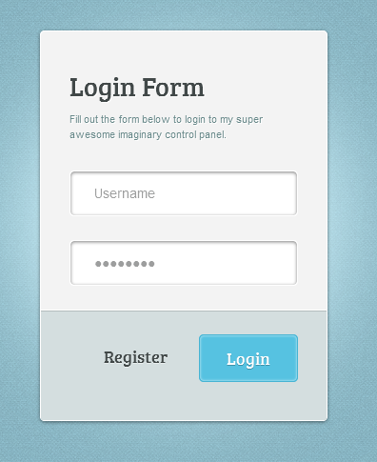**­­­­­­­­­­­­­­**

|  |
| --- |
| **Design above Login page and do following things:-**  **1) New user: redirect to registration page**  **2) Existing user: Redirect to registration page with all the details filled and on click of submit the record should be updated.**  Capture.PNG |

1. **Design this form and display all the details in a gridview also student can do delete and edit operation directly from gridview.**

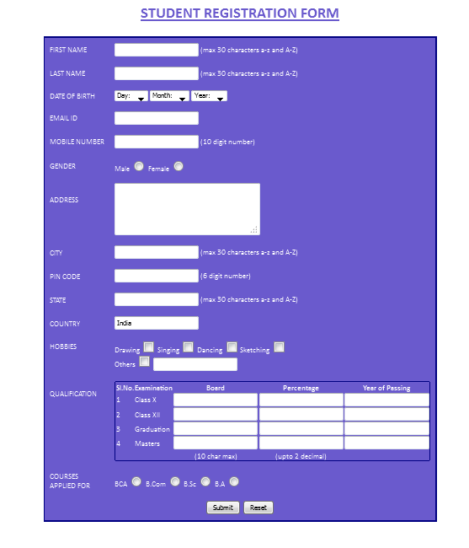

1. Design home page and about us page for hotel website using master page concept.

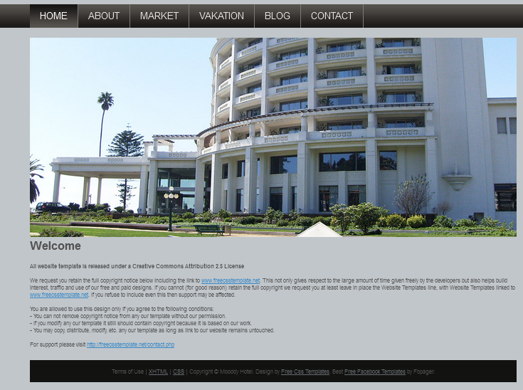

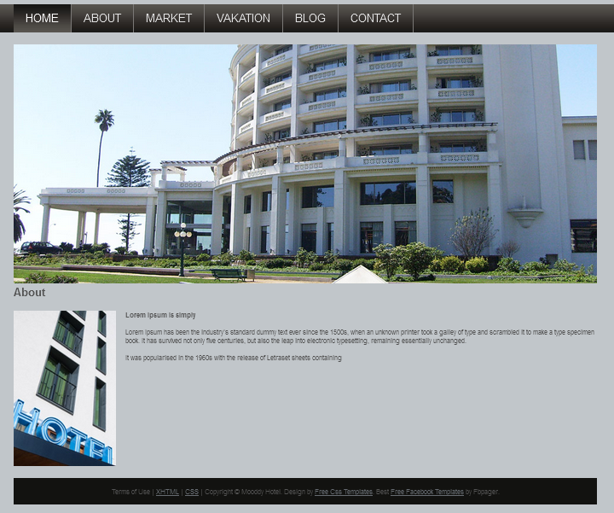

1. Design contact us form for hotel website using already created master page.

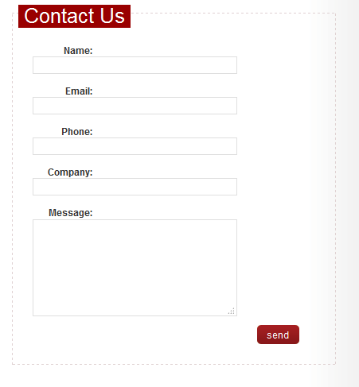

1. Design above gridview and show all employee details from database in gridview. Maximum size of a gridview should be 5 records if more than 5 record exists in database then pagination should be use in the gridview to display all employee records.

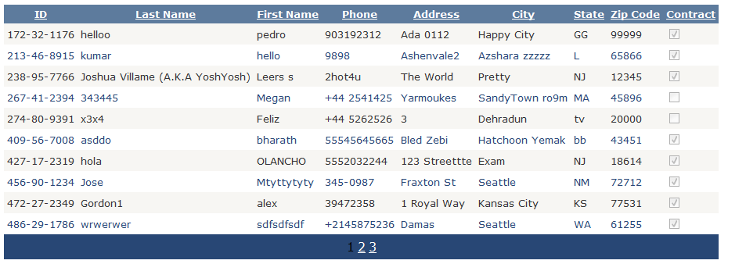

1. Design 2 pages one page contain first name and last name and when user fill both the textbox and click on button then the data should pass to the second page and display data on the second page.

FIRSTNAME

LASTNAME

SUBMIT

1. Design this page and upload a file from the folder and display in gridview and provide a download link inside gridview from user can download these files.

